[E145] Battery

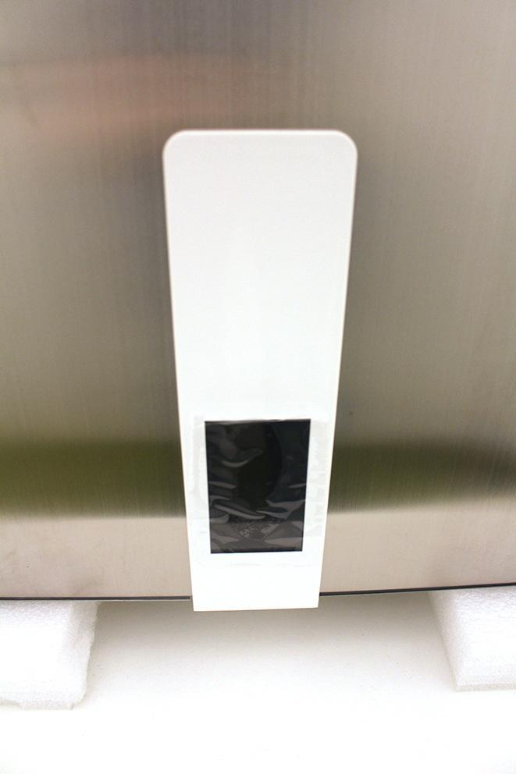

Unscrew the front panel fixing screws.

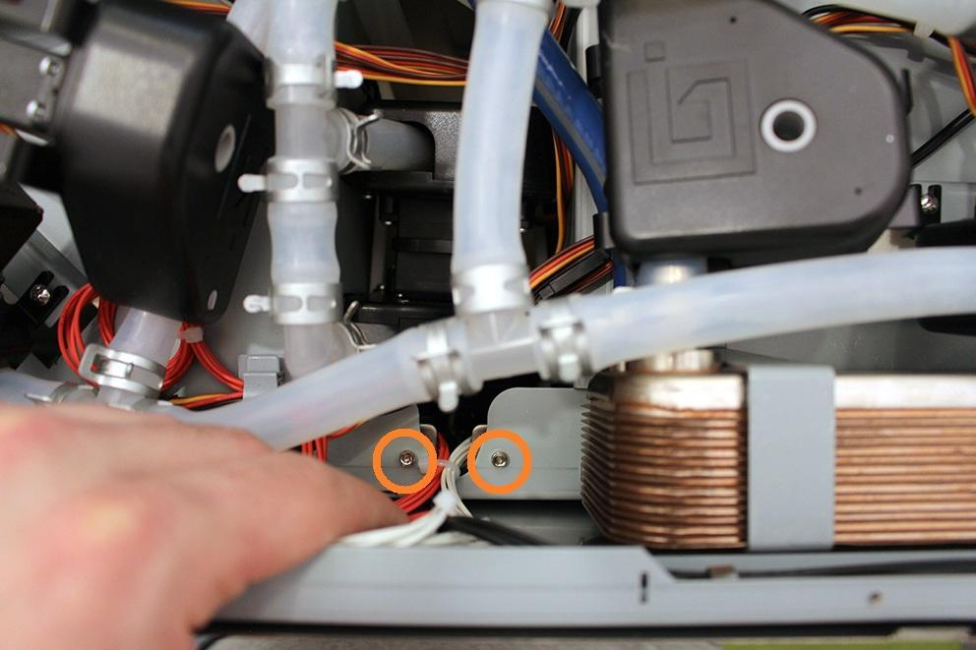

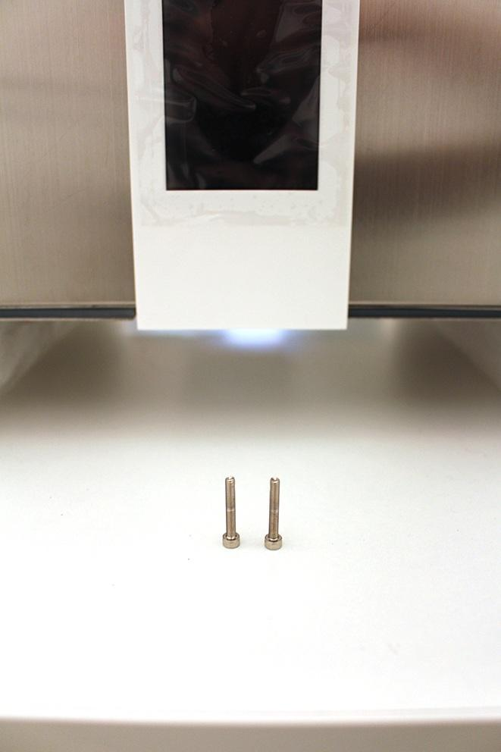

Push down the front panel to pop it out.

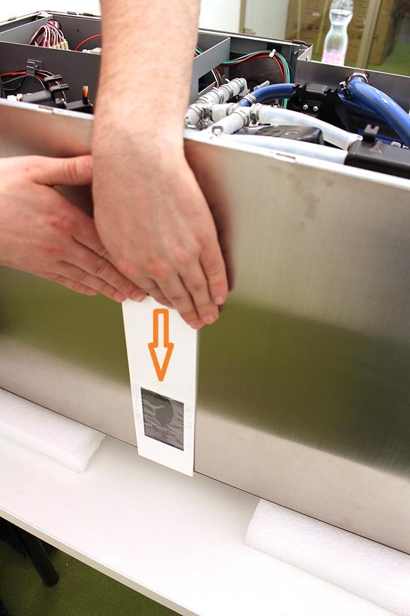

Disconnect the indicated plugs from the front panel.

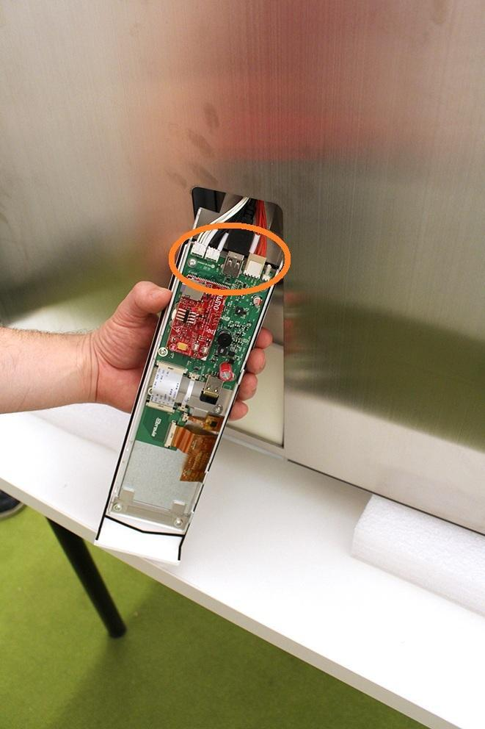

Now you can remove the front panel unit.

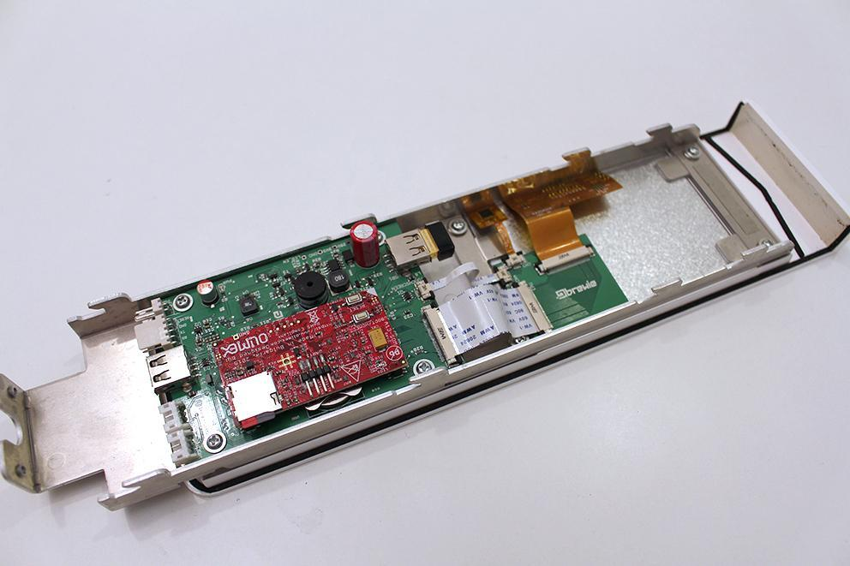

Pop out carefully the black cable lockers and pull off the cables. Be careful - cables can be damaged easily!

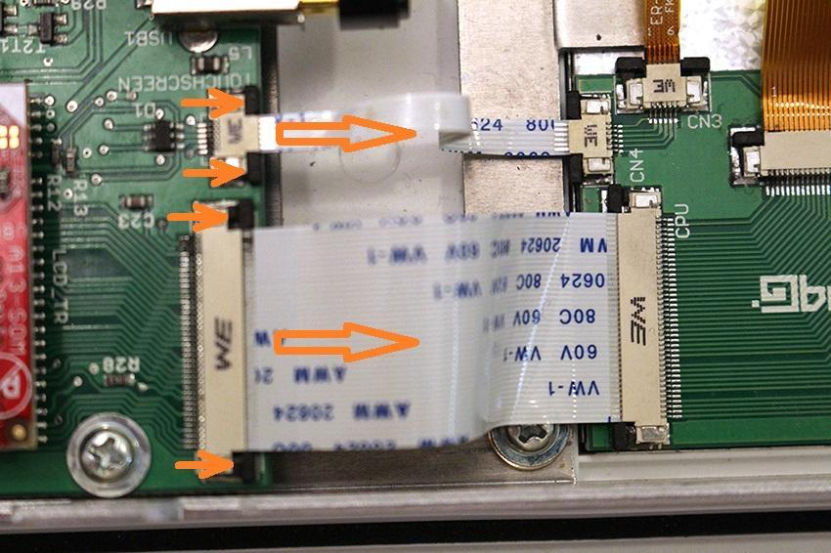

Unscrew the 4 indicated screws.

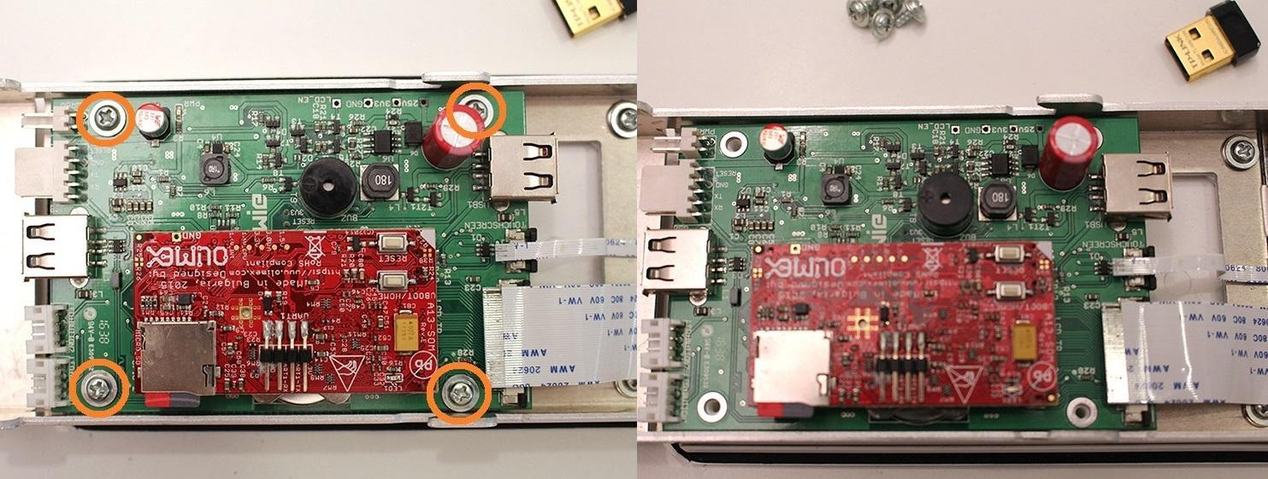

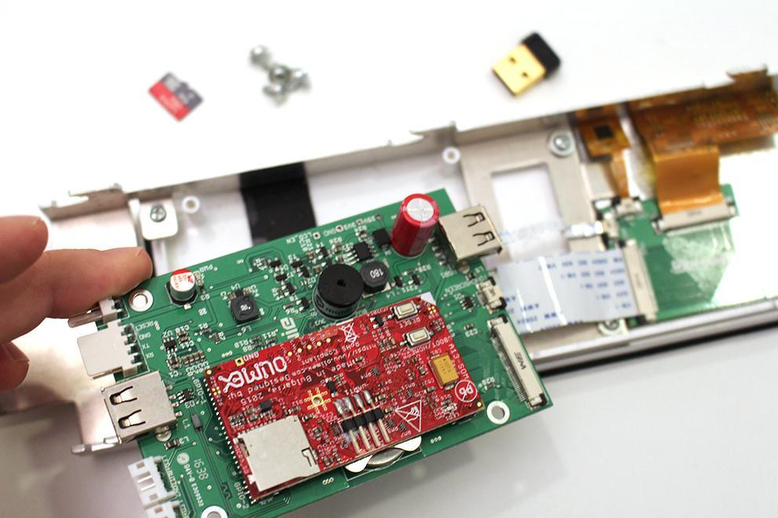

Carefully remove the Olimex panel with a precision screwdriver.

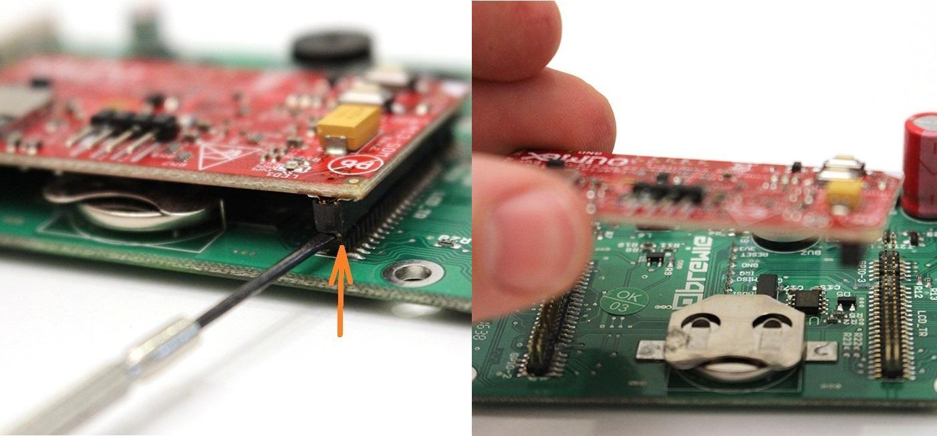

Remove the battery.

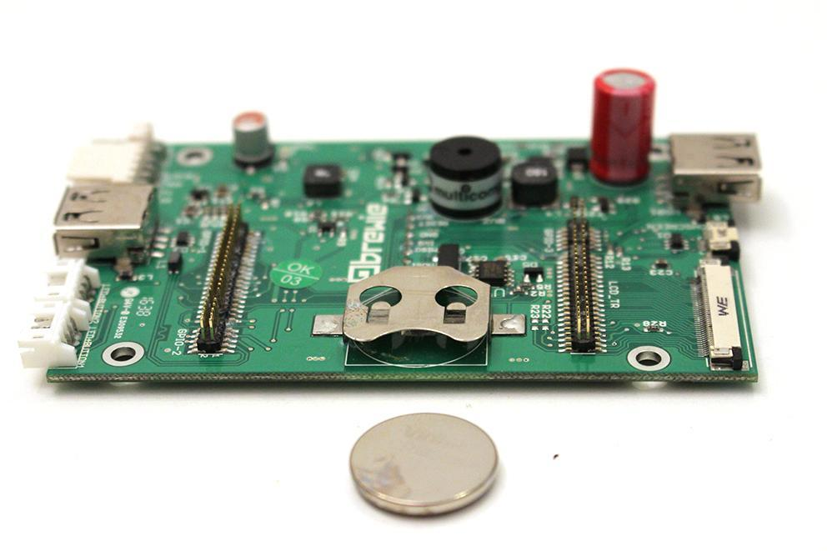

Replace the battery.

Reassemble consists of the same steps in reverse.